Mohammed Ashraf Taha – 617027 – 4CS

Assignment 01

Make A decision tree and production rule for Tail Shape attribute only

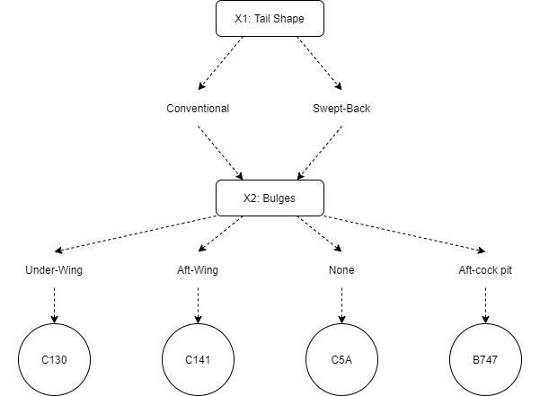Answer:

R1: **IF** Tail Sheap Conventional **And** Bulges Under – Wing **THEN** C130

R2: **IF** Tail Sheap Conventional **And** Bulges Aft-Wing **THEN** C141

R3: **IF** Tail Sheap Swept-Back **And** Bulges None **THEN** C5A

R4: **IF** Tail Sheap Swept-Back **And** Bulges Aft-cock pit **THEN** B747